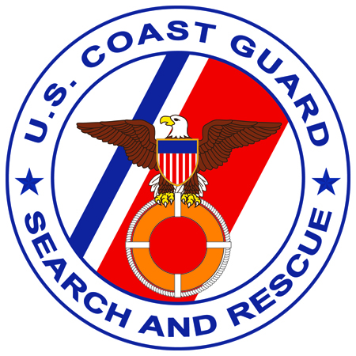
Fact Sheet
Emergency Position Indicating Radio Beacon (EPIRB) and Personal Locator Beacon (PLB) False Alerts:

Background:
Despite prolonged periods of continuous exposure to extreme weather conditions in the marine environment, with minimal maintenance attention, EPIRBs and PLBs are required to be ready to work, without flaw, the first time in an emergency. Satellite distress beacons have saved over 22,000 people world wide since the international Cospas-Sarsat (Search and Rescue Satellite Aided Tracking) System became operational in the 1980’s.

In 2007, distress alerts provided by emergency beacons assisted in saving 353 lives in the United States. Unfortunately, with all the successes attributed to beacons, about 92% of the alerts received from 406 MHz beacons are false. Not only does this needlessly endanger rescue personnel, but it also degrades the search and rescue resources available to respond to actual emergencies.

Roughly 64% of the false alerts in the U.S. are caused by human error during beacon installation, maintenance, testing and disposal. Many of these false alerts could be quickly mitigated with a few phone calls from a controller at a rescue coordination center (RCC) if the beacon is properly registered, but data shows that only 82% of EPIRBs and even fewer PLBs are registered. In the U.S. there are approximately 143,000 registered EPIRBs and 30,000 registered PLBs.

Some important points for the mariner are:

- Class A, B, and S 121.5 MHz EPIRBs became prohibited for use on 01 Jan 2007. Owners with a prohibited EPIRB should replace it with a 406 MHz beacon as soon as possible.
- Beacons designed as man overboard alerting devices are still legal for use since they do not transmit a signal to satellites, but are only used for local homing.
- All 406 MHz EPIRBs and PLBs are required to be registered with NOAA. This registration is free and can be done on the internet (www.beaconregistration.noaa.gov) or mailed/faxed to NOAA. Beacon registrations must be updated at least every two years or when information such as emergency contact phone numbers and other vital information changes. This registration information is protected and only available to authorized search and rescue personnel.
- Beacon owners should prevent mishandling of EPIRBs and PLBs by inexperienced persons to avoid possible damage to the beacon or transmitting a false alert.
- EPIRB and PLB self-tests should only be conducted according to the instructions provided by the manufacturer. This is important to ensure that the beacon is working properly and to avoid an accidental activation.
- EPIRBs, EPIRB mounting brackets or housing units and PLBs should be examined regularly for any physical damage. If there appears to be any damage, corrosion, cracking, water ingress, etc., the beacon should be replaced immediately.
- When disposing of a beacon or taking it out of regular use (i.e.: putting in storage), ensure the battery is disconnected/removed and updates are made to the registration data.

The U. S. Coast Guard Office of Search and Rescue (CG-534) manages the SARSAT program along with partners from NOAA, the U.S. Air Force, and NASA. See the following sites for more information:

USCG Office of Search and Rescue: www.uscg.mil/hq/cg5/cg534
NOAA SARSAT Program: www.sarsat.noaa.gov
U.S. Air Force Rescue Coordination Center: www.1af.acc.af.mil/units/afrcc/
NASA Search and Rescue: searchandrescue.gsfc.nasa.gov
International Cospas-Sarsat website: www.cospas-sarsat.org

