SARSAT Search and Rescue Satellite Aided Tracking
There are three types of beacons used to transmit distress signals:
EPIRBs (for maritime use)
ELTs (for aviation use)
PLBs (for land-based applications)
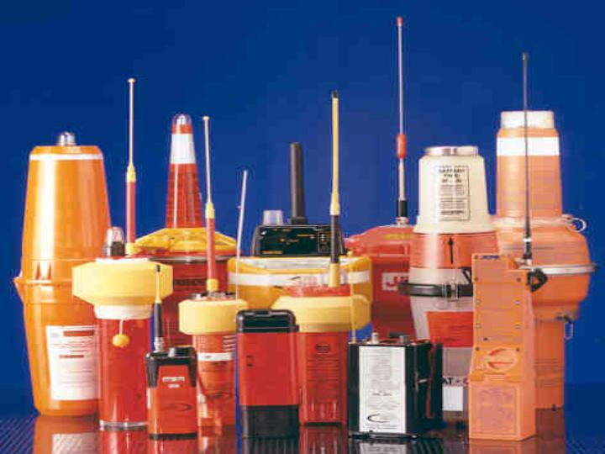
Read below to find out more on these types of beacons…
Emergency Position Indicating Radio Beacon (EPIRB)


EPIRBS are for use in maritime applications. They transmit a digital identification code on 406 MHz and a low-power "homing" signal on 121.5 MHz.
The 406 MHz EPIRBs are divided into two categories:
Category I EPIRBs are automatically activated. The automatic activation is triggered when the EPIRB is released from its bracket. Category I EPIRBs are housed in a special bracket equipped with a hydrostatic release. This mechanism releases the EPIRB at a water depth of 3-10 feet. The buoyant EPIRB then floats to the surface and begins transmitting. If you own a Category I EPIRB, it's very important that you mount it outside your vessel's cabin where it will be able to "float free" of the sinking vessel.
Category II EPIRBs are manually activated. If you own one of these, it should be stored in the most accessible location on board where it can be quickly accessed in an emergency.
If you have a 406 MHz EPIRB their signal can be instantly detected by geostationary satellites. This means that even a brief inadvertent signal can generate a false alert. To avoid getting a call from the Coast Guard make sure that when you test your EPIRB you follow the manufacturer's recommendations carefully. Tests by beacon owners should only be done in the beacon’s “self-test” mode. Or, follow these guidelines for general beacon testing & inspecting procedures.
Also, make certain that you register your EPIRB. Registration will help rescue forces find you faster in an emergency and allow you to make an important contribution to the safety of others by not needlessly occupying SAR resources that may be needed in an actual emergency. To register a 406 MHz EPIRB, you can now register online or you may download a beacon registration form from the registration website and then fax the form to NOAA at: 301-817-4565.
For any other registration questions, please call NOAA at: 1-888-212-SAVE (7283).
Note: Class A, B, and S EPIRBs that operate on the 121.5 MHz frequency became prohibited for use after December 31, 2006.
The U.S. Coast Guard has an outstanding website with even more information on EPIRBs. Click here to view the Coast Guard EPIRB Homepage.
Emergency Locator Transmitters (ELTs)

ELTs were the first emergency beacons developed and most U.S. civil aircraft are required to carry them. ELTs were intended for use on the 121.5 MHz frequency to alert aircraft flying overhead. Obviously, a major limitation to these is that another aircraft must be within range and listening to 121.5 MHz to receive the signal. One of the reasons the Cospas-Sarsat system was developed was to provide a better receiving source for these signals. Another reason was to provide location data for each activation (something that overflying aircraft were unable to do).
Different types of ELTs are currently in use. The older generation 121.5 MHz ELTs have proven to be highly ineffective. They have a 97% false alarm rate, activate properly in only 12% of crashes, and provide no identification data. In order to fix this problem 406 MHz ELTs were developed to work specifically with the Cospas-Sarsat system. These ELTs dramatically reduce the false alert impact on SAR resources, have a higher accident survivability success rate, and decrease the time required to reach accident victims by an average of 6 hours.
Presently, most aircraft operators are mandated to carry an ELT and have the option to choose between either a 121.5 MHz ELT or a 406 MHz ELT. The Federal Aviation Administration has studied the issue of mandating carriage of 406 MHz ELTs. The study indicates that 134 extra lives and millions of dollars in SAR resources could be saved per year. The only problem is that 406 MHz ELTs currently cost about $1,500 and 121.5 MHz ELTs cost around $500. However, no one can argue the importance of 406 MHz ELTs and the significant advantages they hold.
For more information on the differences between 121.5 MHz Beacons and 406 MHz beacons click to view a Comparison.
Due to the obvious advantages of 406 MHz beacons and the significant disadvantages to the older 121.5 MHz beacons, the International Cospas-Sarsat Program have made a decision to terminate 121.5 MHz satellite alerting on February 1st, 2009. All pilots are highly encouraged to consider making the switch to 406!
If you need to register a 406 MHz ELT, you can now register online or you may download a beacon registration form from the registration website and then fax the form to NOAA at: 301-817-4565.
For any other registration questions, please call NOAA at: 1-888-212-SAVE (7283).
Personal Locator Beacons (PLBs)

PLBs are portable units that operate much the same as EPIRBs or ELTs. These beacons are designed to be carried by an individual person instead of on a boat or aircraft. Unlike ELTs and some EPIRBs, they can only be activated manually and operate exclusively on 406 MHz. And like EPIRBs and ELTs all PLBs also have a built-in, low-power homing beacon that transmits on 121.5 MHz. This allows rescue forces to home in on a beacon once the 406 MHz satellite system has gotten them "in the ballpark" (about 2-3 miles).Some newer PLBs also allow GPS units to be integrated into the distress signal. This GPS-encoded position dramatically improves the location accuracy down to the 100-meter level…that’s roughly the size of a football field!
The FCC authorized the use of PLBs in the United States in 2003.
Prior to July 1st, 2003 only residents of Alaska had been able to use PLBs. The Alaska PLB Program was set up to test the capabilities of PLBs and their potential impact on SAR resources. Since March of 1995, the experiment proved very successful and helped save nearly 400 lives while generating only a few false alerts. The success of the Alaska PLB program undoubtedly paved the way for nationwide usage of these devices.
If you need to register a 406 MHz PLB, you can now register online or you may download a beacon registration form from the registration website and then fax the form to NOAA at: 301-817-4565.
For any other registration questions, please call NOAA at: 1-888-212-SAVE (7283).

